Service For the Lord’s Day

First Presbyterian Church
Starkville, Mississippi

Third Sunday of Advent
December 17, 2017

Prelude Angels We Have Heard on High Balcombe
Jennifer Blackbourn

Welcome

*Introit (11:00 – Chancel Choir)

*Call to Worship
Lighting the Candle for the Third Sunday of Advent
(8:30) The Robby and Foley Holditch Family
(11:00) The David and Mandee Lewis Family
Prayer of Invocation and Praise

* Advent Hymn 176 Come Thou Long Expected Jesus HYFRYDOL

Prayers of Confession, Petition and Intercession
The Lord’s Prayer (Unison)
Our Father, Who art in heaven, hallowed be thy name. Thy kingdom come, thy will be done, on earth as it is in heaven. Give us this day our daily bread; and forgive us our debts, as we forgive our debtors; and lead us not into temptation, but deliver us from evil. For Thine is the kingdom and the power and the glory, forever. Amen.

Silent Prayers
Good News of God’s Grace

*Hymn 670 The Gloria Patri

Anthem (11:00 –Chancel Choir) Bethlehem Larson

Advent Gospel for Young Disciples Martin Lifer

*Affirming Our Faith: The Apostles’ Creed (Traditional) (Unison)
I believe in God the Father Almighty, Maker of heaven and earth, and in Jesus Christ his only Son our Lord; Who was conceived by the Holy Ghost, born of the Virgin Mary, suffered under Pontius Pilate, was crucified, dead, and buried; He descended into hell; the third day
He rose again from the dead; He ascended into heaven, and sitteth on the right hand of God the Father Almighty; from thence He shall come to judge the quick and the dead.
I believe in the Holy Ghost; the holy catholic church; the communion of saints; the forgiveness of sins; the resurrection of the body; and the life everlasting. Amen.

* Responsive Hymn 668 - The Doxology

*Giving to God: Tithes, Offerings, and
First Things First Pledges

*Prayer of Thanksgiving and Dedication

Offertory O Come, All Ye Faithful arr. Hayes
Jennifer Blackbourn
_______________________________________________________________________________
*The congregation is invited to stand.

Deacon of the Week: Joel Downey and John Rush
Today’s Ushers: (8:30) Ross Collins; (11:00) Kenny Lacey
Today’s Greeters: (8:30) Carolyn Coleman; (11:00) Mallory Lacey

The Sanctuary Flowers are given to the Glory of God by Dr. and Mrs. James Long in memory of their parents.

The Proclamation of God’s Word

Sermon Series Glory to God!

Scripture Luke 1:34-38; Matthew 19:25-26; Ephesians 3:20-21
(ESV Pew Bible pp. 855, 824, 977)

Sermon With Him, Nothing Is Impossible Martin Lifer

Invitation to faith; Prayers of Trust in God’s Grace

*Hymn 63 Awesome God AWESOME GOD

*Benediction

Choral Response (11:00 – Chancel Choir) Amen traditional

Postlude Intermezzo on “Carol of the Bells” arr. Dixon
Jennifer Blackbourn
_____________________________________________________________________________________________________________________________________
*The congregation is invited to stand.

Visiting with Us?
We warmly welcome you to our worship of God and to visiting our other ministries and being back in worship with us on upcoming Sundays.
Please speak to Pastor Martin Lifer following today’s service (outside the front entrance), … or contact him this week at the church office or via email (mwlifer3@gmail.com). Let us know of any special prayer requests, or if you would like to learn more about growing in your faith or, specifically, about joining our church family.
___________________________________________________________________

Adult Sunday School Fellowship Groups Meet 9:45-10:30 a.m.
We also invite all guests and members – if you are not already in a Sunday School Bible Study & Fellowship Group – to join us on Sundays, 9:45-10:30 a.m., for one of the following:
Crusader Class (Fellowship Hall)

Discovery Class (Johnson Room – Church Office Bldg.)

Faith for Life (Chapel – behind the Chancel front of the Sanctuary)

Joy Class (Parlor)

New Covenant Class (Main Room on the Balcony Floor of the Sanctuary)

Women in the Word (Room S-6, main Sanctuary Floor)

_______________________________________________________________________________________

DIAPERS & WIPES SHOWER THIS MORNING!
In addition, join us this morning during our Fellowship Gathering (10:30-10:50 a.m.) in Fellowship Hall for our Diapers & Wipes Shower for Edward and Leah Kemp, and for their coming son (due to be born on or before the early days of the New Year).

_______________________________________________________________________________________________________________________________

FURTHER MISSION MINISTRY NEWS & OPPORTUNITIES:

Help us Ring the Red Kettle Christmas Bell to Raise Funds for the Salvation Army Mission Campaign - outside the Starkville Kroger this Saturday, December 23 (9am to noon, 2-7 pm). Please – individually or with family members or friends – sign up for one-hour slots on the sheets posted on the chalkboard in the Fellowship Hall.

TEJERAS MEAL SPONSORS (Mission meal for children in Tejeras, Honduras)
December 20 and 22 – Anonymous Supporter to the glory of God in appreciation of FPC Deacons and Elders

CASSEROLE KITCHEN MISSION MEAL HOSTS AT FPC THIS WEEK
Dec 12 – Paula Ivey Dec 14 – Bob Boyd

BEGIN NEXT WEEK’S CHRISTMAS CELEBRATIONS
WITH US HERE AT FPC
NEXT SUNDAY, DECEMBER 24TH

- ADULT SUNDAY SCHOOL CLASSES (9:45-10:30 a.m.);
Children’s Sunday Classes will not meet,
but we will have CHILDCARE for children, 9:30-Noon

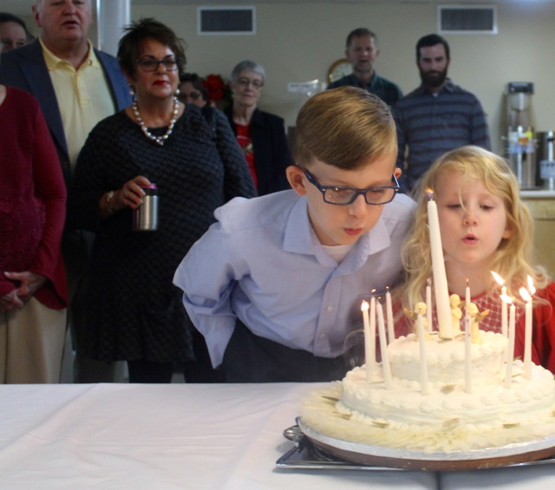
- BIRTHDAY CAKE FOR JESUS
at our FELLOWSHIP GATHERING (10:30- 10:50 a.m., Fellowship Hall)

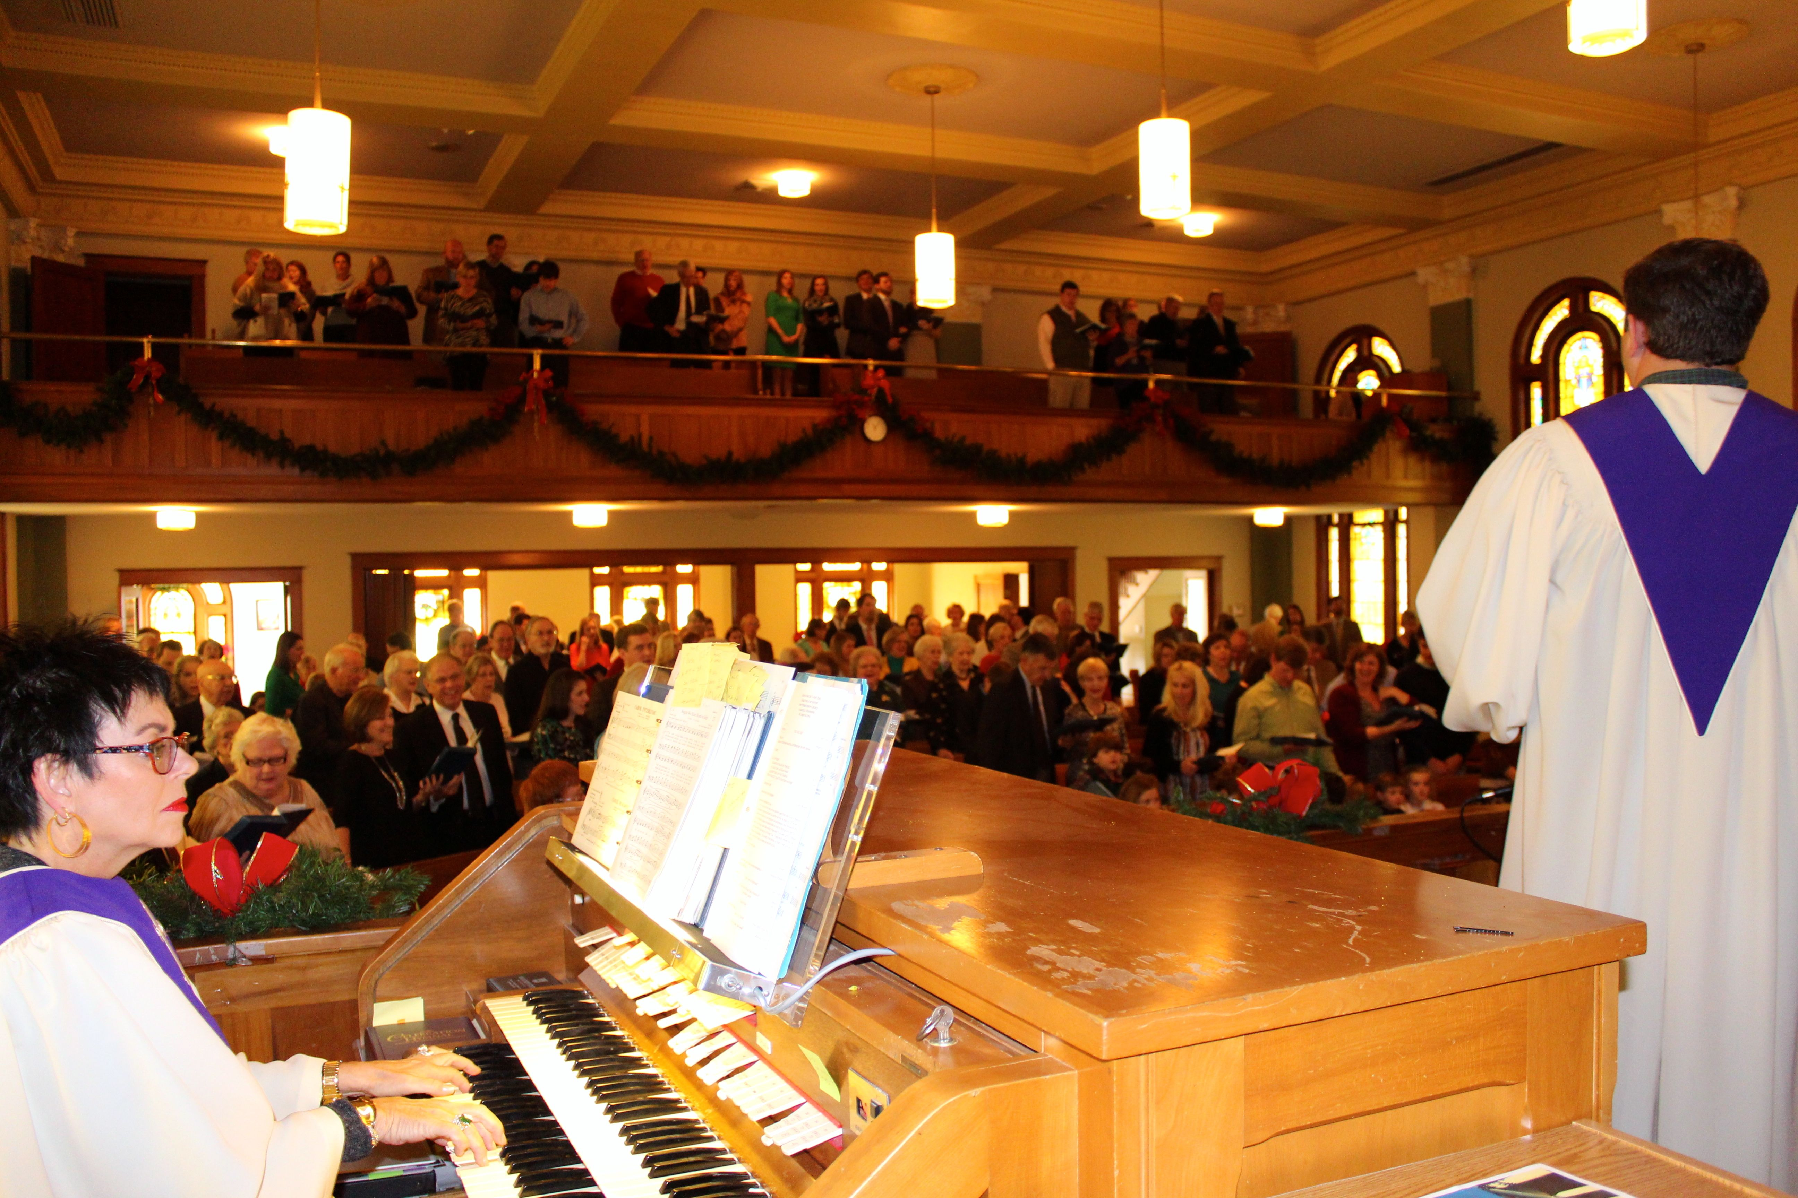

- Our ONE Dec. 24 SUNDAY MORNING WORSHIP SERVICE
at 11:00 a.m. (Sanctuary).
We’ll sing a couple of extra Christmas songs, looking ahead to…
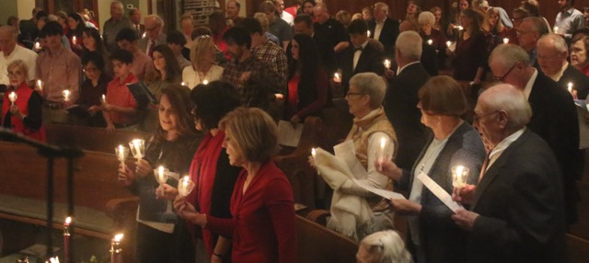

CANDLELIGHT CHRISTMAS EVE COMMUNION SERVICE
5:00 p.m. (Sanctuary),
with childcare provided in the Christian Education Building

Other UPCOMING FPC CHRISTMAS ACTIVITIES & WORSHIP

____________________________________
Date | Time | Event
Dec 17 | 6 pm | Crusaders Sunday School Class Party – J-3 Ranch
Dec 31 | 8:30 & 11 a.m. | CHRISTMAS SEASON SUNDAY WORSHIP  (1st Sunday in Christmastide)

Pastoral Note: Happy 68th Anniversary (yesterday) to Joe and Carol Mobley!

Women’s Wednesday Night Bible Study Coming in January:
Tired of Chasing Perfection? Turn to Jesus! We Saved You a Seat.
An Invitation for Women: Join us beginning January 2018, on Wednesday nights after Friends and Family dinner in the Parlor for a 7-session DVD driven women’s Bible study focused on increasing our capacity for meaningful friendships with other women. We Saved You a Seat is a study by Lisa-Jo Baker and friends from (in)courage, that explores our relationship with Jesus as the ultimate model for authentic friendship. Nothing shapes us like the impact of a friend - it's how Jesus radically and intimately connects with us. So instead of chasing perfection, overcome your fear of being known and find the courage to connect. To sign up and order a workbook, please contact Orly Hardin obh2@msstate.edu

Week of December 17, 2017
SUNDAY: 8:30a.m . Worship Service
9:45 a.m. Sunday School
10:30 a.m. Fellowship Gathering (Fellowship Hall)
11:00 a.m. Worship Service
MONDAY: 7:00 p.m. Boy Scouts (Boy Scouts Building)
8:00 p.m. Narcotics Anonymous, also on T, W, & F (Ed. Bldg)
TUESDAY: 7:00 a.m. Men’s Prayer Breakfast (Parlor)
6:00 p.m. Casserole Kitchen (Fellowship Hall)
WEDNESDAY: 7:30 a.m. No Friends & Family until Jan 17, 2018
THURSDAY: 6:00 p.m. Casserole Kitchen (Fellowship Hall)
SATURDAY: 6:00 p.m. Narcotics Anonymous (Christian Education Bldg.)

Prayer List
Thomas Guest (Charlie and Rubye Guest’s grandson)
Hawkins Murdock
Robert McDavid
Mary Jo Wallace and Family
Rusty Bouchillon
Diane Daniels, together with her sister, Delores Irvin, and Sarah Helen McCloskey (Daniels’ family friend) -PA
Jane Zitta
Sylvia Love
Marjorie Malone
Cynthia Ware, together with her parents, Donna and Herman Ware
Eleisha G. Reynolds (Anita Reynolds’ daughter-in-law) Montrose, CO
Marie Tubb and John Gassaway (Anna Ray Gasaway’s sister-in-law & brother-in-law)
Dawn Allen (Nell Hartness’ granddaughter) - Starkville
Billy and Brenda Harrington
Cattie Taylor
Carol Clark (Albert Clark’s sister)
Brenda Pratt, Cheryl Kay Linder (Beth Ann Dunlap’s stepmother & sister)
Bessie Montgomery
Mae Glass (Vivien Miller’s mother)
Carl Ivey, Sr. – Dukedom, Kentucky
Anderson Ivey (Carl and Paula Ivey’s grandson) – Birmingham, Alabama
Marshall McReynolds (Sherylan Webb’s nephew) – Tupelo
Craig Wolf (Paula Elliott’s son-in-law) – Huntsville, Alabama
Danny Carlisle (Loren Zimmerman’s friend)
Frances Ellis, Christopher A. Cook, and Brett Horton (Ellen Mauldin’s sister, grandson – U.S. Army-Poland – and her brother Leslie’s grandson)
Billy Ray Ball (Dolph Bryan’s Uncle) – Tuscaloosa
Madeline Bell (Greta Bryan’s great niece) – Vienna, Virginia
Jack Boren & family, Ryan Carrithers, Tonia McLendon, and Sue Salley (friends of Dolph & Greta Bryan)

Health Care / Assisted Living Prayer List
Jane Lusk – The Claiborne
Jetta Kuykendall – The Grove, Columbia
Kathleen Smithson Lawson – Vicker’s Personal Care Home
Lu Graham (Jane Zitta’s sister) – The Hermitage, Richmond, Virginia
Frances Oakley – Sunnybrook Estates, Madison
Marie Tramel – Beau Ridge, Ridgeland
Maxine Eastland – Franklin, TN
Elizabeth Duffey – Presbyterian Village, GA
Jewel Jacobs (Cindy Walker’s mother) – Montgomery Garden
Thelma Gentry – Vicker’s Personal Care Home

Elders
2017  Larry Anthony  Jim Beaty  Charlie Guest  Loren Zimmerman | 2018  Myles Carpenter  Jack Forbus  Randell Foxworth  Allen Johnson  Janice Kinard  Perry Rackley | 2019  Dolph Bryan  Harold Clark  Cecelia Cook  Bob Daniels  Orly Hardin  Edward Kemp
Elder Emeritus – Dero Ramsey

The Session’s next Stated Meeting is December 17, 12:30 p.m. / Dr. Martin Lifer, Moderator / Randell Foxworth, Clerk
Deacons

2017  Wesley Ferguson  Brien Henry | 2018  Ellen Boles  Jay Cook  Michelle Jones  John Rush | 2019  Peggy Branch  Vivian Cade  Joel Downey  Jimbo Hearnsberger  Jason Ryder
The Diaconate meets Sunday, Jan. 7, 12:15 p.m. / Wesley Ferguson, Chair / Joel Downey, Secretary
Session and Diaconate Ministry Committees
(*Current Elder, **Current Deacon)
Worship & Music  *Larry Anthony, Chair  Fellowship & Hospitality  **Jay Cook, **Joel Downey,  **Jason Ryder, Co-Chairs  Adult Discipleship Education  *Allen Johnson, Chair | Missions  *Dolph Bryan, *Loren  Zimmerman, Co-Chairs  Shepherding  *Janice Kinard  Communications & Outreach  *Orly Hardin, Nancy Lifer,  Co-Chairs  Childcare Board of Directors  Zack Harrington (Chairman)  Cecelia Cook  Amanda Henry  Will Rackley  Sarah Ryder | Children’s &  Youth Ministry  *Janice Kinard,  *Orly Hardin, Co-Chairs  Budget & Finance  *Bob Daniels, Chair  *Jim Beaty, Treasurer  Personnel  *Perry Rackley, Chair  Property  *Myles Carpenter,  *Edward Kemp Co-Chairs

FPC Women’s Ministry – Caitlin Rackley, Moderator
Circles meet 2nd week of each month (7:00 pm Circle meets 3rd Monday)
Circles, Meeting Places, and Leaders

Sunday 8:00 am, Parlor –  Lynda Forbus | Tuesday 6:00 pm, Nancy Lifer's Home –  Orly Hardin
Monday 1:30 pm, Parlor–  Kay McReynolds | Monday 7:00 pm, location TBA –  Amy Aarhus
Men of the Church (MOC) Officers – Andrew Fountain, President,
Will Rackley, Vice President, Charlie Weatherly, Treasurer
The Ministry of Music
On Wednesdays - Chancel Choir, 6:00 p.m/. Children’s Choirs at 5:50 p.m.

FPC and FPCCC Ministry Team
Rev. Dr. Martin Lifer, Pastor mwlifer3@gmail.com
Rita Usher, Pastoral Secretary info@fpcstarkville.org
Ashleigh Murdock, Children’s Ministry Coordinator aabmurdock@gmail.com
Dr. Craig Aarhus, Music Director aarhus@bellsouth.net
Jennifer Blackbourn, Organist jenniferblackbourn@hotmail.com
Kathy McGill, Children’s Choir Director katherinemcgill@hotmail.com
Alexis Thibodeaux, Student Assistant for Youth Ministry alexis.nicole.thibodeaux@gmail.com
Ellen Mauldin, Church Librarian mem3@bellsouth.net
Amanda Corley, Child Care Director fpcccdirector@fpcstarkville.org

First Presbyterian
Church,
Starkville

A Congregation in the Evangelical Presbyterian Church –
A Global Movement of Evangelical Christians

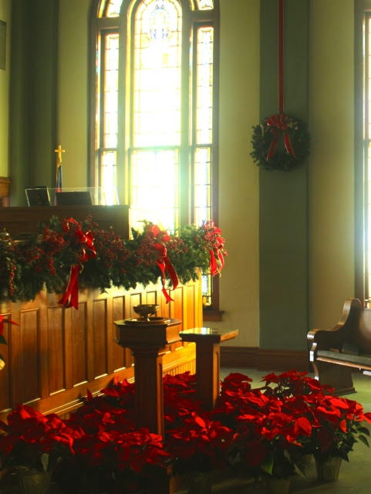

December 17, 2017
3rd Sunday of Advent

Worship Service | 8:30 a.m.

Sunday School | 9:45 a.m.

Fellowship Gathering | 10:30 a.m.

Worship Service | 11:00 a.m.

Visit Our Website for Ministry Resources and News
www.fpcstarkville.org

Church Office
307 University Drive
Starkville, Mississippi 39759
Phone | 662-323-1994
Fax | 662-323-1999
Office Hours
Mon. - Friday: 9:00 a.m.-12:00 a.m. & 1:00-4:00 p.m.

